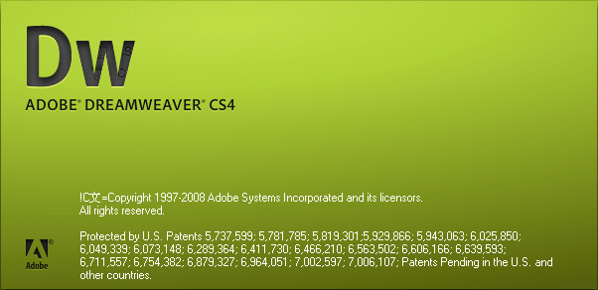

VCE 2 – Information Technology Applications
Macromedia Dreamweaver MX :: Skill Development Folio
Preparation for Unit 3 – Outcome 2

Your task is to create a website on a topic approved by your teacher.

The following features of Dreamweaver will need to be incorporated into the production and successful navigation of your website.

Your checklist: (tick off as you go…)

Basic | Intermediate | Advanced
- Anchors  - Background Colors  - Bulleted List  - Font Color, Size and Face  - Hyperlinks  (Relative & Absolute Links / Internal & External Links)  - Images - Still and Animated Images  - Physical Styles – Eg. Bold, Italic, Underline  - Text Alignment | - Tags  (Alt & Metadata)  - Audio Visual Files  - Background Images  - Not tiled  - Not scrolling  - Opacity  - Change the Default Color of Hyperlinks  - Frames  - Image Hotspots  - Linkable Images  - Rollover Images  - Shared Borders  - Sound Files  - Style Sheet  Standard / Layout Views – Tables & Cells  - Table/s  - Targets (Frames)  - Flash Objects  - Text  - Buttons | - CSS Style Sheets  - Forms  - Menu and Navigation  - Mouse Trailers  - Page Transitions  - Scroll Bar Colors  Highlighted features need added code – see next page for resources.

Features’ Support

Color Charts
http://www.w3schools.com/html/html_colors.asp

Menu and Navigation
http://www.dynamicdrive.com/dynamicindex1/

Mouse Trailers
http://www.dynamicdrive.com/dynamicindex13/trailortext.htm

Page Transition Effects
http://www.see-search.com/webdesign/PageTranstition.htm

Scroll Bar Colors
http://www.codemaker.co.uk/it/tips/colorscrollbar.htm

<style
type="text/css">
<!--
BODY
{
SCROLLBAR-FACE-COLOR: #000099;
SCROLLBAR-HIGHLIGHT-COLOR: green;
SCROLLBAR-SHADOW-COLOR: #000000;
SCROLLBAR-3DLIGHT-COLOR: #009999;
SCROLLBAR-ARROW-COLOR: #33FFFF;
SCROLLBAR-TRACK-COLOR: #003366;
SCROLLBAR-DARKSHADOW-COLOR: #666666;
}
-->
</style>

